THE NEW DUSTSHEET
NEWSLETTER OF THE FRIENDS OF THE RECORD OFFICE FOR LEICESTERSHIRE, LEICESTER & RUTLAND
NO 11 SPRING 2019

NO 10 autumn 2018

The Forward O.P.

The Dustsheet is more news-sheet than magazine this time, as it carries the latest on the projected Record Office move as well as the official notice of the A.G.M. There is more to this than just notices however, no matter how important they are this time. We can read about the Blaby shooting, in an account penned by a user of the Record Office. Let there be more such contributions! Please read the note from Shirley too about a possible new collaboration with our chums in the Family History Society.

The mailing brings news too of our new website and the role you can play in promoting and testing it. Take careful note of the accompanying details of the A.G.M.; which is your chance to have a
say and influence the activities of your society. We hope to see you on 22 May.

Robin Jenkins
Senior Archivist (Collections)

Collections and Learning Hub Development

As you may be aware Leicestershire County Council has allocated capital funds for the development of a new Collections and Learning Hub on the County Hall site at Glenfield, Leicester.

The development of this new facility, which will bring together Archive, Museum and Creative Learning collections and resources on one site will be delivered in two phases.

The first phase will be the re-location of the Record Office into a new building at the side of the Penn Lloyd building on the Glenfield Road.

The building project will include new strong rooms with capacity for the current archive and Local studies collections and 25 years of growth space to ensure that the collections remain relevant to Leicester, Leicestershire and Rutland’s communities and to maintain our status as an Accredited Record Office under the National Archive’s Accreditation scheme.

Plans are at an early stage and we are working with colleagues across the County Council and with our partners at Leicester City and Rutland County councils to determine a timetable for the construction work, preparation of the collections to move to their new home, and the physical move and re-opening of the service.

The current plan is to have the new Record Office open to customers by 2023.
Further updates will be provided as the project develops. If you have any concerns or questions about this new development in the meantime, you can contact Robin Jenkins or Jenny Moran, Senior Archivists at the Record Office at: recordoffice@leics.gov.uk

Philip Warren
Collections and Learning Manager
FRIENDS OF THE
RECORD OFFICE

I recently met Mick Rawle from the Family History Society who I am sure many of you will know.

We discussed how our two organisations the Friends of the Record Office and the Family History Society might work together.

The Family History Society are discussing setting up a help desk at the Record Office to help and advise customers who are new to family history research.

If any Friends feel they might volunteer to help in this venture please contact the Record Office and we will pass on your details.

I hope many of you will attend the AGM in May; it would be good to see you there.

Shirley Hensman
Chair of the Friends of the Record Office

THE BLABY SHOOTING CASE : 1883

The pleasant weather on the evening of Monday, 30th April 1883 tempted the young ladies and gentleman outside to play tennis on the Rectory lawn. Local boys also gathered, a noisy crowd, to sit on the wall and watch.

Charles Leakey, the 18-year-old son of Blaby's Vicar, didn't like every serve to be commented on and jeered at by scruffy children and told them to go away. Naturally, they didn't, so he sent his younger brother, Bertie, to fetch the gun.

"But take the shot from the cartridge and load it with salt", he said.

When Bertie returned, Charles loaded the gun and pointed it at the boys. All but one jumped down.

"Go away", he shouted.

The remaining urchin didn't move. Steadying the gun, Charles fired. The boy fell off the wall onto the road outside.

Labourer, Thomas Hill, who lived nearby, heard the gun and saw the boy in the middle of the road. He later told the police, "He was staggering as though he was about to fall".

The boy, 8-year-old Aaron Abrahams, said, "Leakey shot me". Then he fainted and was carried home by other witnesses.

Hill climbed the wall and asked Charles if he knew what he'd done.

Charles replied, "He's not hurt is he?"

"He is", Hill said. "Why did you shoot him?"

"He wouldn't get off the wall", Charles said.

Aaron's father sent for the police. When PC Kirk arrived, the child was lying on two chairs, unconscious. He examined the lad, finding a small wound and two pieces of shot lodged in the clothing.

Edward Croucher, the surgeon, arrived and confirmed the boy had a small puncture wound on his left breast, over the third rib.

"I can't say for sure what caused it", he said but when pressed by the police, admitted it might have been a gunshot.
Charles attended the County Police Office on the following Wednesday and was charged with unlawfully and maliciously wounding Aaron Abrahams. In court, Mr James, (Wright, Williams & James), prosecuting, said the boy wasn't in a fit state to be present and asked for a week's remand.

Mr Haxby, (Haxby & Partridge), appearing for the defence, pointed out that his client had attended the court without a summons, merely at the request of the police, but nevertheless, he wouldn't object to a remand.

The case was remanded for a week and Charles left the court with his friends.

The trial was held on Wednesday, 9th May. The charges were read: that Charles Montague Leakey maliciously wounded Aaron Abrahams with intent to do grievous bodily harm, with unlawfully wounding the same person and of assaulting him, occasioning him actual bodily harm.

He pleaded, "Not guilty".

Mr Williams, prosecuting, said a young man, in whatever social position, could not shoot at boys with impunity and the only offence of which the child was guilty, was a desire to see a game of tennis. He said that 14-year-old Bertie had been told to extract the shot from the cartridge but unfortunately, not all the shot was removed.

Aaron was called and sworn in. He said he'd climbed on the wall to watch a game on the lawn. The Vicar's son never told him to get off, but just fired at him. He said he fell off the wall and felt, "something sticking in my inside".

Other witnesses were questioned and when the prosecution had finished, Charles was formally charged. He said, "I deny the charge".

Mr Haxby then addressed the Bench. He said he agreed with the prosecutors observations and did not ask for any sympathy for the defendant because of his social position, and if he did, it would be of little use as County Magistrates were known to deal out justice with an even hand.

"The defendant", he said, "took every precaution to avoid doing harm to the boy. The shot had been removed from the cartridge, which was filled with salt, so as to give a loud retort and frighten the boy off the wall".

Robert Herbert Leakey was called and stated he'd been careful to see that no shot was left in the cartridge before giving it to his brother. Other witnesses were called to corroborate this.

Mr Haxby said that, sadly, the press had made a great deal of Mr Leakey's conduct, but he wished to assert that the defendant was extremely sorry and had expressed regret about the situation.

The Magistrates retired to deliberate, but returned after ten minutes, the Chairman believing this was a case over which his Bench had no power. The defendant was therefore committed for trial at the next Assizes, on the third charge only, that of Assaulting Aaron Abrahams, occasioning him actual bodily harm. Bail was granted.

Mr Haxby said he was sorry to see a young gentleman of such standing in this position.

The Summer Assizes opened on Thursday, 12th July 1883 at Leicester Castle, with Judge Baron Huddleston presiding.

The Grand Jury decided the offence seemed to be one of common assault and not one of occasioning actual bodily harm and the charges against Charles Leakey were therefore reduced to one of common assault.

Mr Lloyd, prosecutor, stated that he wished to make an arrangement with the boy's family, the latter being desirous of coming to an amicable solution. The prisoner's family was greatly grieved at what had taken place and had offered to make such compensation as would be thought sufficient. He asked that the charge of common assault be withdrawn and sought his Lordship's permission to make such an arrangement, that compensation be made to the boy.

The Judge said, "I don't think we can go into that".

Addressing the Court, he said the prisoner had not shot at the boy with intent to do grievous bodily harm and directed the Jury to return a verdict of, "Not guilty".

The Jury did so and Charles left the court with his friends.

Source
Leicester Daily Post: 2,3,10 May 1883 and 12,13 July 1883
(The Record Office for Leicestershire, Leicester & Rutland)

This article is the work of Glen Lee a customer of the Record Office. Her facts all come from local sources, Blaby, Glen Parva and Whetstone and The British Newspaper Archives.

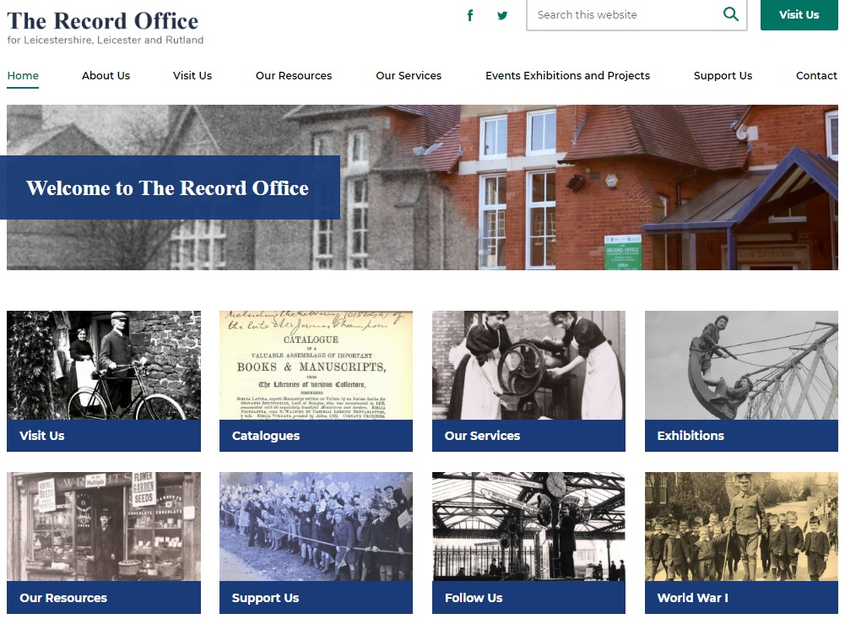

RECORD OFFICE NEW WEBSITE GOES LIVE!

Our long-awaited and much-improved new website was launched at the end of March. We were pleased to secure the simple domain name :

www.recordoffice.org.uk

We are still working on some additional text and images, along with checking and fine-tuning, but all the main content is now available. The new site is more modern and comprehensive than its predecessor and has a responsive design, making it compatible with PCs, tablets and mobile devices. There is up-to-date visitor and service information, detailed resources, online exhibitions, useful links, legacy pages for the Century of Stories project and much more – including, of course, Friends’ and Volunteers’ pages. The site also allows us to show off themed images from our collections.

We hope you find the new website user-friendly. All comments will be very welcome and valuable for making improvements. Is there anything missing and is it easy to navigate and find what you want? Please send us your feedback using the contact details on the website, or just speak to a member of staff if you’re visiting.

