THE NEW DUSTSHEET
NEWSLETTER OF THE FRIENDS OF THE RECORD OFFICE FOR LEICESTERSHIRE, LEICESTER & RUTLAND
NO 10 autumn 2018

NO 10 autumn 2018

The Forward O.P.

Speaking from atop the rickety chimney, I would say that the metaphorical land roundabout (through my field glasses) seems green and pleasant, fertile and well-ploughed. To judge from their newsletter, the Friends seem to be on the road to somewhere interesting and worth reaching. There is a long way to go perhaps but our companions are agreeable and good company.

I’d be pleased to have this bumper publication shoved through my letter-box. There is a friendly greeting from Shirley Hensman, the new woman in the chair. I know Shirley means what she says when she urges you to think about the future and to let us know what you think.

The rest is the usual mixture of information and entertainment. There are some useful and inspiring reports on the doings of the Friends and of the Record Office. We meet new members of staff and say goodbye to old friends.

There is also valuable guidance on the manufacture of ‘inke’ (which I shall put to the test) and some wind-baggy tosh on postcards. You may not wish to plough through so much verbiage but I urge you to do so. There is an exciting competition at the end which I am certain you will wish to enter.
Robin Jenkins, Senior Archivist (Collections)

FRIENDS OF THE
R.O. L.L.R.

As the new Chair of the Friends I was interested in looking at the activities of similar Friends groups. I looked at many groups throughout the country, not quite Lands End to John O’Groats, but almost.

In all of them their aims, as are ours, is to provide practical, volunteers etc. and financial support. They also, in many cases have an active social programme with lecture series, organised trips to places of interest and get-togethers for a meal and discussion.

Would Friends be interested in these sorts of activities if they were arranged?

As well as meeting other Friends with the same interests it would also be a way of raising funds.

I would be interested in having your views on this and any other issues you might like to raise.

I can be contacted by email hensmanshirley@gmail.com or messages left at the Record Office reception will reach me.

I look forward to hearing from you.

Shirley Hensman, Chair of FROLLR
GDPR FORMS:
Exciting and important!

The new Secretary to 'The Friends', Roy-Anthony Birch, wishes to thank all those who have already completed and returned their General Data Protection Regulations (GDPR) forms to the Record Office, thereby giving us permission to keep in touch with them. This, after all, is just what we want to do, and Where would we be without you? There are, however, a number of members who seem not to have returned the forms, and Roy would be extremely grateful if they could do so as soon as possible, giving permission for us to maintain contact either by e-mail or by traditional post.

Blank forms are available from Reception at The Record Office, offering the option of completing one on the spot and helping to ensure that your details are added to our contact list almost literally there and then. As an alternative, and especially for those who might not expect to visit the Record Office within the next week or two, Roy is perfectly happy for you to give permission direct on his e-mail address, indicating whether e-mail or post is your preferred option. E-mail him on
roy.birch867@btinternet.com

Likewise, if there are any problems, say for example, that you remain uncertain as to what may be involved in your competing the form, then please ring Roy direct on (0116) 276 5931 or 07989 985763 (02 mobile). Roy adds that the whole thing is actually quite straightforward, and wishes to assure everyone that any and all personal information held by The Friends will be treated with the utmost confidence; just as it should be!

Roy-Anthony Birch
Secretary, FROLLR

Friends Indexing Projects

Marriage Affidavits DE1947 & Leicestershire & Rutland Asylum Admission & Discharge Register DE 3533-146

These are the two indexes that have recently been completed, firstly Marriage Affidavits 1896-1969 over 15,000 entries in all. These are applications to the archdeaconry for a licence to be granted for a marriage, the information that can be found includes the date of application, the name of the applicant and their intended, where they were from, age and status i.e. single or widowed, if they were juveniles the name of the parents or guardian and the name of the church that they were to be married at. In the case of girls who were marrying American or Canadian service men it usually gives some details of military background but the original document needs to be seen to get this information quoting the reference number along with the box & entry number. It can be seen from the information given quite a large percentage of the girls marrying service men were well under the age of consent. For those searching these indexes bear in mind that just because they applied for a licence they did not necessarily marry.

Secondly the Admission and Discharge register for the county asylum 1907-1947, having 3,640 entries. The first list from this register gives the names of the patients when they were admitted and the place they were from and the second when they were discharged or died and in some cases the condition they left in’ i.e. cured or improved. Our thanks go to Phil Stone and John Gillam who compiled the asylum lists.

Laurence Lock is in the process of indexing Theatre Programmes, most of the larger theatres have been completed and he is now working on the smaller theatres.

Quarter Session Conviction
Registers QS85/2

The next project which we have made a start on is the above registers which will be in index of Conviction Certificates; there are 12 surviving registers for various types of offence commencing in 1842 most of them running up to 1915.

John Savage,
Projects Coordinator, FROLLR

Goodbye Hello

Sorry to misquote the famous Beatles song! Earlier this year we were very sad to say goodbye to the two long-standing members of staff: Jo Buckley retired in May and Kasia McCabe left to take up a new post at County Hall in June. We wish them both well and are happy to welcome their replacements to our team: Corey and Karima! Corey is joining us from the libraries service, whilst Karima is a former teaching assistant and nurse. Both have a lot of experience in working with documents and helping people with enquiries, and have settled in well – if you are a regular visitor you have probably already seen them around. We hope they will be very happy with us.

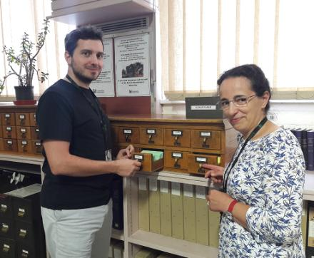

“Off on your holidays next week?”

Said one of our customers in the week before our annual stock-taking closure. “Ha!” we thought, “if only…”. So what actually happens when we’re closed in the first week of October?

Well, ‘stock-taking’ is an umbrella term covering a number of tasks which it is difficult or impossible to complete whilst we are open. It does not usually mean, literally, taking stock of our holdings, although counting, numbering and sorting collections all feature at some point.

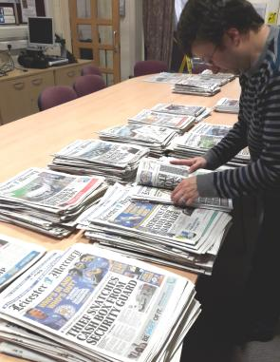
Preparing newspapers for filming

It is our chance to take in and process large quantities of material: in this case, the Coalville Times from 1898-1981 arrived at our out store on the County Hall site. Because of the closure we were able to station three members of staff to receive them. Anyone who has browsed through local newspapers will know what a fascinating source of information they are – a truly unique record of events great and small. We are very grateful to Amalia Kuchlin of the Coalville Times for depositing them with us. She and her family have been involved with the paper for many years and understand the importance of these resources as well as having an exclusive insight into the effort it takes to produce them!
We use stock-taking as a chance to spruce up the public rooms and some of you may have noticed the horrible stain on the ceiling in Searchroom One where there was a leak some months ago. The height of the ceiling makes it impossible for contractors to work safely on a scaffolding tower when we are open, so we have now been able to get it patched and painted. We have also been able to replace old notices and worn-out labels, tidy and re-order the shelves, clean the machines and put books and catalogues back into order. Our trusty carpet-cleaning team came on Friday to complete the job – we hope you notice the difference!

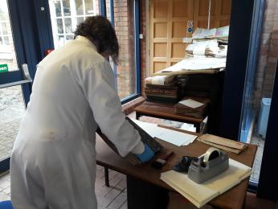
Conservation work

Probably the biggest impact is behind the scenes, when we can get to grips with jobs in the storage areas. We hold millions of individual items – large and small- so it is essential that we can keep track of them all, store them safely and, of course, make them available. Stock-taking gives us the opportunity to work in a more concentrated way on these tasks, and to use all the rooms to sort and box new collections. New accessions have been cleaned and packaged by Karenna, our Conservator, who also did an emergency planning refresher for the staff, so we know what to do in the event of a problem. Harborough District Council, Charnwood Borough Council and Melton Mowbray parish records have been catalogued, boxed and space created in storage areas by sending some material off site.

Hundreds of new entries have been added to the online catalogue – now one of the main ways people locate the information we hold.

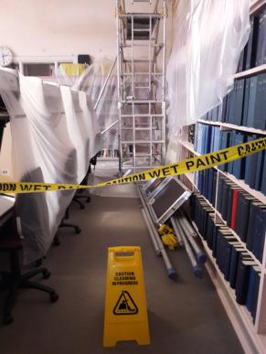
Ceiling repairs

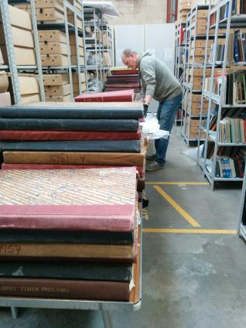
Coalville Times

Stock-taking week is always very satisfying (I hope colleagues agree) in terms of achievement, impact and camaraderie so we always like to share our successes with Dustsheet readers. We hope you feel, as we do, that the closure has been worth it and you can see the fruits of our labours.

Jenny Moran, Senior Archivist (Access & Information)
“First to make inke in divers maners” : Iron gall ink on paper

Iron gall ink was the standard writing ink in the western world from the 5th to 19th century and is found in vast quantities throughout paper and parchment archives today – you’ve probably seen it many times on old documents ‘in the flesh’ or on television programmes. It is a blue/black or brown/black ink made from iron salts and tannic acids. It fell out of use when commercially made inks appeared in the 19th century.

Iron gall ink components:
Galls [tannins] are odd shaped spherical growths formed on oak trees by gall wasps during the larval stage of their development [March- October]. The galls have no deleterious effect on the tree. If there’s a hole then the wasp has emerged. Different galls = different colour inks.
Iron sulphate [ferrous sulphate, vitriol, copperas]
Water [wine, vinegar, beer]
Gum Arabic [a water soluble gum or binder- keeps the black pigment suspended in liquid and thickens it enough to flow easily for writing/drawing]
Logwood [a colourant-water soluble and fugitive]

How the ink was made:
The crushed galls were mixed with water to release tannins, which react with iron sulphate to form a dark-coloured solution. Gum Arabic was added to ease the flow of ink in quill pens and later, in metal-nib pens. The writing won’t appear dark black when first written as it needs to oxidise in the air. Thus ink darkens over time. To bypass this, darker colours were added. Natural dyestuffs, including logwood, indigo, and Brazilwood were used until synthetic aniline dyes replaced them in the late 19th century. Indigo had the further advantage of imparting a preservative effect to the ink.

Problems for the conservator:
The recipe and ingredients determined the stability over time. Excess of iron led to ink corrosion and degradation by iron catalysed oxidation and acid hydrolysis. This leads to acidic paper, discoloration and holes – as you can see from the pictures. Variations of homemade recipes resulted in different coloured inks and strengths - thus some are dark, some brown/orangey and some more acidic than others. Moisture in paper or the storage environment contributes to acid hydrolysis which leads to the breakdown of the cellulose chains that make up paper= loss of strength, embrittlement of paper sheet and dropping/cracking of letters. Iron gall ink ‘sets’ into the paper rather than sitting on the surface- thus paper manuscripts and documents can be washed in water- a common conservation practice. However, some more soluble parts of the ink may be diluted by doing so.

Solutions:
The inherent alkaline nature of parchment tends to slow the rate of any potential acid degradation.
Early treatments to combat acid attack in paper manuscripts-such as lining with paper, silk or cellulose acetate did not stop the acidic degradation of the paper they were supporting; and in some cases accelerated it. Other treatments tried to reduce acidity and not the oxidation.

Keeping paper in a stable environment and in dry conditions will help. Paper treatments to counteract acidity have been developed but are usually wet processes e.g. deacidification which can cause future problems by adding too much moisture. Recent research from The Netherlands has led to the introduction of ‘Fe Migration test papers’ and ‘re-moistenable’ fine tissues. These allow the conservator to spot test and then use a thin repair tissue using minimal moisture to conserve the documents.
Spectral imaging systems have different wave bands on the light spectrum that can be used to identify iron-gall ink non-destructively, to determine the condition of historical ink, to evaluate treatment, and to enhance faded and illegible texts – so hopefully these records will be useable for many years to come!

Haloing of brown/orangey ink: DG 24/45 copy of will 1655
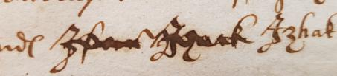

Haloing of dark brown ink :DG 24/25 1741
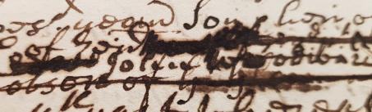

Dropped/cracked letters: DG 24/25 1741
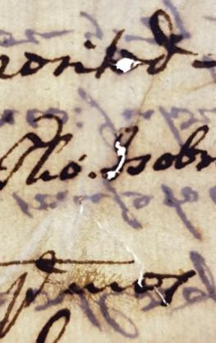

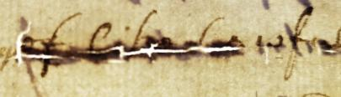

Recipes and detailed references available upon request – please contact us.

Karenna Fry
Archive Conservator
CHRISTMAS AND NEW YEAR 2019

Now Bonfire Night is over and twinkling lights are being erected on the High Street, our thoughts turn to Christmas and what 2019 has in store.

Firstly, we will be closed on:
Monday 24th December
Tuesday 25th December
Wednesday 26th December
Friday 28th December
Saturday 29th December
Tuesday 1st January 2019

The days we are open are:
Saturday 22nd December 9.15-12.15
Thursday 27th December 9.15-5pm
Monday 31st December 9.15-5pm
Wednesday 2nd January 9.15-6pm then we are open our normal advertised hours.

A reminder that in December and January the Record Office closes at 6pm on Wednesdays.

Plans for 2019…

Collections Hub
We are expecting a decision early in the new year on the project to bring heritage services together under one roof. We will keep you informed of developments.

New Website
Our new website should be fully operational in January and we will be looking for some volunteers to test and comment on it. If you want to help us please take a look at www.recordoffice. org.uk/home and email comments to the secretary of the Friends at roy.birch867@btinternet.com

Manorial Documents
We will be making a big splash with our manorial documents project so watch out for more information on these fascinating and under-used resources.

We would like to wish you all a happy and peaceful Christmas and New Year from all of us at ROLLR.
£0.00416 well spent

From time to time the editor of the Dustsheet is pleased to publish an article from me reporting on new arrivals in the Record Office. By ‘new arrivals’ I mean newly deposited or otherwise acquired material, which I think might be of some general or topical interest. Fortunately, there is much to ‘go on’, as we regularly receive donations or deposits of striking or useful archives.
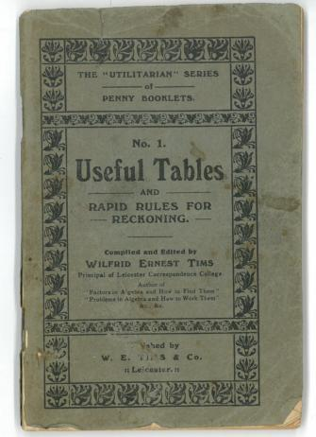

I fear I may, in my excitement, sometimes forget to give our library its due attention. Let me say it clearly now then that we also are constantly adding to our holdings of local printed material – books, pamphlets and periodicals. All these are worthy and every bit as interesting (often) as their manuscript counter-parts. In any case, let me rectify the omission with a small chirrup for Useful Tables compiled and edited by Wilfrid Ernest Tims, of Sidney Road, South Knighton; the Principal of Leicester Correspondence College, in 1908.

It is a delightful little booklet; number one of ‘the “Utilitarian” Series of Penny Booklets. The others, I guess, were equally useful, covering such subjects as Useful Rules for Correct Spelling and Useful Information for People who Read and Write. The emphasis was clearly on the useful, and trust me, no archival researcher should be without a copy. Some of Mr Tims’s tables are merely a reminder for us but others are truly breaking new (old) ground.

For example, we cricketers know only too well that 22 yards makes a chain because, of course, that is the distance between wickets. It is as well to know too that there are 10 chains in a furlong and 8 furlongs to the mile. “But what about square measure?” You ask. Well, it is all there; square chains, square poles, roods and acres. All very useful, I fancy, for understanding those deeds and enclosure awards.

You will also find liquid measure, dry measure (2 gallons to the peck, 4 pecks to the bushel, and 8 bushels to the quarter, etc) and apothecaries’ measure. I know it hardly matters any more but you will also find a detailed explanation of the metric system and its intriguing prefixes. Everyone knows that a kilo-something is what Mr Tims calls a “1000 times Unit” but did you know Hecto is 100 times and Myria 10,000 times? I’m not sure I did and with the admirable Mr Tims at my disposal I now need not try to remember it!

I cannot say how fascinating some of the tables are. I am not so sure about their usefulness however but it may just be a failure of my imagination. Or perhaps I am not as practical a fellow as I think. I can just about see why someone might wish to know that a farthing is 1/960th of a pound (and £0.0010416) but what use can knowing that 1/2880th is a twelfth of a penny (or £0.0003472)? Anyway, it is all there in black and white.

I did enjoy the table of foreign and colonial money. Half the fun, I always think, of foreign travel is the amusing currency they all seem happy to use. Think of the innocent pleasure the Euro has stolen from us: for 9½d you could have had 100 Stotinkis in Bulgaria; or 100 Banis in Roumania; or a Lira in

Italy, Dinar in Serbia and, of course, a Franc in France. An American dollar was worth 4/1½ (just a ha’penny less than its Spanish equivalent).

Finally, I mustn’t forget the table for builders. This is a truly useful table, which tells me the area of a ‘load’ of 3-inch plank (200 square feet if you must know) and that while a ‘load’ of lime is 18 bushels, a ‘load’ of sand is 21 bushels. Of course a ‘hundred’ of nails is

actually 120, just as a ‘hundred’ of lead is 112 lbs. Rather in the style of a baker’s dozen, I suppose. I also now know that a ‘Case’ of glass is 45 Tables and that a ‘Table’ of Glass is the equivalent of “5 Feet Super” but (in all honesty) I haven’t the foggiest notion what it means.

It is a jolly pamphlet to be sure and made all the jollier by the profusion of local advertisements, which are scattered throughout. Like most adverts, these are a reflection of their times and a wonderful document in themselves; from G.J.B. Woolley’s “High Class Dentistry…Artificial Teeth in Gold, Dental Alloy, or Vulcanite…” to Cadoux’s Balsam, which was “for Coughs and Colds, Spitting of Blood, Pleurisy, Asthma and all Chest Affections…Post Free ¼ and 3/2.”
Robin Jenkins

Clerical Scandals?

We are always pleased to hear about your research projects and the curious and interesting facts they throw up. Please do not hesitate to send in anything which you think our readers might find of interest. We are indebted here to Mrs. Greiff for this sidelight cast from her own studies upon some of the rogues in vestments who, from time to time, have populated Leicestershire’s pulpits.

Dr. Elias Travers was Rector of Thurcaston in 1621-1641, being the first appointee of Emmanuel College, Cambridge. The parish was in a truly disordered state after decades of incompetent regulation by absentee clergy, but the population became very resentful when Dr Travers finally swept in for the first time in 1628, to impose the strictest of Puritan behavior on the parishioners.

Though, as is clear from his will, he was very good friends with Mr John Willows, Vicar of Mountsorrell, Mr John Angell, the ‘Confrater of William Wiggstone’s Hospital’ and Mr. Thomas White, Vicar of St. Martin’s in Leicester, there were a number of local clergy we may be sure Dr. Travers would not have counted among his circle.

In the difficult years of the 1640’s and 1650s, many clergy were deprived of their livings and a fascinating register of these, with biographical details, was compiled by John Walker called ‘Suffering of the Clergy during the Grand Rebellion 1642-1660’.¹ Although the

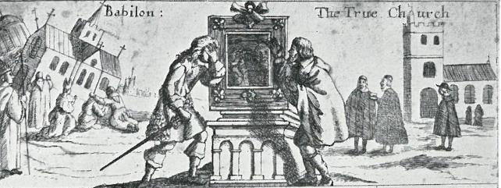

period covered is after Dr. Traver’s death, some records relate to ‘misdemeanors’ of previous years. A few examples enlarge the picture of the type of behaviour there had been.

Robert Bailey, Vicar of Oadby, 1634: “fought and quarreled in ale-houses” “profaned the Sabbath, letting his children play”
“his wife seldom at church”
“often in Leicester”

Richard Benskin, Rector of Wanlip and Vicar of Humberstone
“refused to take the Covenant”

Joseph Smith, Rector of Sileby and Swithland (and later also of Hathern). He spent his time “hunting and hawking” and for two years lived in the Royal Garrison in Leicester.
He “kept scandalous curates
at Swithland and paid them only 40s p.a.” He was also
accused of excessive drinking.

Many were stated to engage in fights, to frequent alehouses, be neglectful, and engage in swearing, not observing the Sabbath, and consorting with the Garrison in Leicester. One was accused of wearing his surplice when he went hunting. It got torn and he made the parish pay for its replacement. In his defence he said it was not torn and only needed washing!

¹ Matthews, A.G. (1948) Walter revised: being a revision of John Walker’s Sufferings of the clergy during the Grand Rebellion, 1642-1660. Oxford, Clarendon Press.

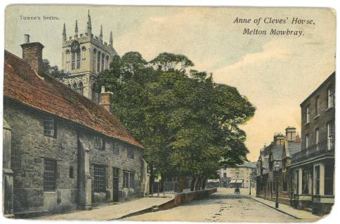
Behind the Scenes

Probing the Potential of Postcards

I must say that I like postcards. I like them professionally, as an archivist, and I like them off-duty, as it were, as a tourist. Often, when unleashed for a spell from search or strong-room, I find myself contemplating the racks of postcards in churches, museums, art galleries or just newsagents in holiday places.

Part of my idle contemplation of what are, to be honest, often uninspiring views of the town hall, or slightly oddly coloured floral displays, is killing time while someone purchases locally made biscuits or visits the nearby lavatories. However, the other part is the knowledge that every now and again I will find a gem that I simply must buy. I might post it to a friend, put it on the mantelpiece, or slip it carefully into an appropriate book, to reappear and please me again in the future. Postcards are pretty versatile.

I like a good clear picture of a tomb or wall-painting, or perhaps a detail of one. I like aerial views of fortifications and to my mind, a good regimental museum is one which has provided satisfactory postcard reproductions of its Richard Simkins watercolours. Every regiment has them – detailing different orders of dress at significant dates – and all good museums will sell you copies. The best museums will also sell you a mug with them on but that is a different story.

So, I like postcards now. I also like historic postcards. As far as archival postcards are concerned, I think they are instantly pleasing and extremely useful. They provide an instant ‘snapshot’ of the past –literally so, I suppose. If you wish to gain some visual insight into the world your ancestors inhabited, you cannot do better than to scan a few postcards. You will find great-grandfather in his bowler hat, striding up Granby Street; or perhaps great-grandma under her parasol waiting for the tram.

Gaze into their world. The quality of both photography and reproduction is usually good enough to allow a pretty close examination. You can see what is on sale in the shops and where the ‘buses are going to. Deploy your magnifying glass and you might even be able to read the posters on the wall; what is on at the theatre, or how much a new saucepan would cost in 1905.

These are the ordinary, everyday views. Luckily, such was the market in those days and such the skill or ingenuity of the photographers, that any happening, any occurrence out of the ordinary, was snapped and sold. Were the Territorials at camp – snap them. Did a waggonette fall over on the hump-back bridge? A fire at the thatched cottage? Or are ladies after the vote again? Set up the camera and sell some postcards.

An accidental boon to the archivist – when the postcard has been posted – is that it always carries a postmark. Occasionally they are obscured but often there, for the poor cataloguer, is a clear indication of a date. The image may be a year or so old but the message (even undated) will have a date and sometimes even a time of posting! It is a marvel how many postal collections and deliveries there were – but because they were so frequent and efficient postcards quickly came to be seen as a useful means of simple communication and arranging social intercourse.

It is often said that it was the great Mr Gladstone who popularised the use of postcards for swift, brief messages. The postal rate was lower and the Post Office sufficiently efficient to make postcards almost the e-mail of those days. In 1870 the Post Office even introduced prepaid postcards, without a picture, just for such simple communication. If The Grand Old Man used them, then they must be respectable. Perhaps the value is enhanced too because the need to find pen and ink, and then walk to the post-box, also concentrated the mind of the sender, who had to encapsulate his or her needs into a short (but to the point) message.

Picture postcards gradually crept in during the 1890s, growing rapidly in popularity if not quality. Now of course it is possible to take your own seaside view, transferring your digital image to one of a number of on-line providers, who will print both image and your message and post a ready-made, personal postcard for you. It is a nice idea but you can’t always guarantee fine weather and what about my aerial view of the town walls? That view is beyond the average tourist unless he (or she) habitually travels with a drone.

My dear wife says she does – but that is another story…

My taste for postcards however is not only for the picture on the front. No, I am also a great reader of other people’s messages and believe me, they can be just as pleasing and easily as enlightening as any view of the High Street in 1911 (hand-tinted or not).

I have decorated this little ramble with a pretty view of Melton Mowbray. The scene hasn’t changed much since the card was printed, although the horse manure has given way to a seemingly endless stream of traffic. Perhaps we are lucky that noise is not a feature of modern postcards! The card comes from a nice little collection – DE9642 – which happily illustrates my other point, that the messages ‘behind the scenes’ can be just as illuminating as the picture on the front.

The Gill family of Holwell were great believers in the postcard as a swift means of communication. The modern equivalent would, I think, be the text messages people send these days on their mobile ‘phones. In fact, ‘E.M.P.’, writing to Miss Gill, would fit perfectly into the current ‘I’m on the train’ mould. His message, on the back of a view of Melton church was simple:

I am writing this in
the train, so excuse
“wobbly” writing
I caught my train
All right
With love
E.M.P.

The Gills also used their postcards to arrange meetings and to conclude business. It is a tribute to the efficiency of the Edwardian Post Office that correspondents could routinely make arrangements for the following day, secure in the knowledge that cards would be delivered in plenty of time. Another view of Melton church, sent by ‘Emmie’ to ‘Hetty’ in August 1905 simply asked:
Will you kindly lend Mother your little pie mould, bring it tomorrow if you are coming in.

Auntie Bessie also chose a postcard as her means of communication. Her urgent despatch to Holwell was also addressed to Hetty and, presumably, was the answer to an earlier question – possibly also sent by postcard:
“When the Raspberries are ripe I should like 12 lbs if Mother can spare them…”

It is the sort of inconsequential message that sinister spies whispered to each other in the films and television series of my youth. This, though, is the genuine voice of Edwardian Melton and its day to day business. Auntie Bessie was clearly about to make her jam for the year and was taking up her sister’s offer of raspberries when they were ready.

Sometimes, of course, the information on the back of the cards is helpful and important rather than merely satisfying of our desire for century-old tittle-tattle. One example will suffice. It comes from a large album of postcards (Ref. DE9310) and is a ‘snapshot’ of Leicestershire territorials at their camp near Whitwick a few years before the Great War. They are a smiling, happy line of lads all ready in their walking-out dress, swagger sticks under their arms.
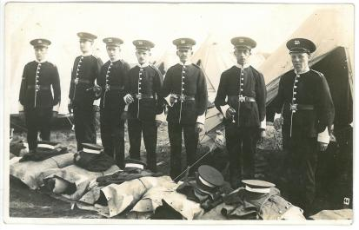

So far so good; a useful photographic record. What makes it twice as valuable is the scribbled note on the reverse which identifies all but one of the soldiers. Here they are: Chapman, Flewett, Sharp, W H, Short, Taylor and ‘?’. There is always one person in a photograph whose name won’t quite come.
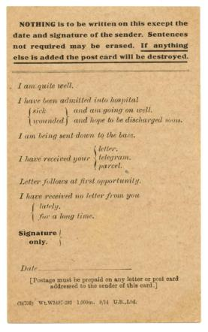
While on the subject of military cards, the value of information (even on the back of a postcard) became all too apparent during the Great War and we have all seen the War Office’s response. The Field Service postcard would be a perfect tool for the taciturn holiday-maker; communication is simply by crossing out pre-written sentences that do not apply.
I am quite well or I have been admitted into hospital sick and am going on well. I have received no letter from you for a long time…

Think of the marketing potential!

I am in Bognor Regis. I am having a super time. The weather is fine/wet/awful. I will be home tomorrow/next week/soon.

I shall conclude with a dramatic declaration. Prompted by own admiration for postcards, I am happy to announce a truly wonderful competition. It will be cheap and easy to enter, beneficial to the archival collections and above all, FUN.

To enter, all you have to do is to send me a postcard (to R P Jenkins, at The Record Office, Long Street, WIGSTON. LE18 2AH). Any postcard will do but if it happens to be a local one it will be added to our collections here and will be a boon to generations of researchers yet unborn. That is the real point. Of course you must write a message on it and we shall consider both the card and its message when deciding upon the winner. The Prize will go to the card we consider best – and we deliberately leave this vague as an added enticement for you to give full rein to your inventive, imaginative and competitive urges.

The prize (and I hope readers will excuse the apparent immodesty of this) will be a copy of my book Leicestershire: The Photographic Collection, which contains a few postcards and many other interesting images of Leicestershire People and Leicestershire at War. The judges will be the two Senior Archivists and Shirley Hensman, the Chairman of our Friends, whose presence will at once guarantee fair play and sound common sense. So good luck and don’t forget to put a stamp on your entry!

Robin Jenkins, Senior Archivist (Collections)

